Computer Language Coding Concepts

Value Get & Set
The principle of values adds the following commands to the system objects related item and related list item:

Value . Get
Value . Set

With these system commands, you can assign the value of a sub-object.

Values are assigned to objects, but value assignment can only be done through an object reference. When you assign a value to an object, you assign it to the object through a related item or related list item.

By default the Value . Get and Value . Set commands just return and set the value. But calls to Value . Get and Value . Set can also be extended with procedures around the assignment or retrieval, as explained in the section Extending the System Interface.

The system members Value . Get and Value . Set are part of the system interface of a related item or a related list item and displayed in a diagram as follows:

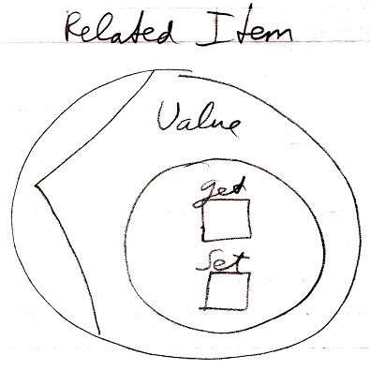

See also: System Objects, Related Item, Related List Item, Extending the System Interface

Author & Copyright: Jan-Joost van Zon Date: June 14, 2008 – June 24, 2008 Location: Oosterhout, The Netherlands Status: Finished

